2024 PEANUT -POPCORN SALE

Important Peanut/Popcorn Dates:
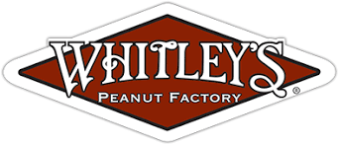
Sale begins on:
Peanut/Popcorn Kickoff: Date Location Peanut/Popcorn Pickup: Date Location Sale ends on:
Money turn in date:
Please make all checks payable to:

Sales Goals and Fun Adventures
Remember to “Do Your Best!” Practice selling with your Scout. See sample script below. Our unit peanut/ popcorn sales goal is $
Each Scout's sales goal is $ . By reaching this goal, the following will be paid for...

Here are a few of our upcoming Scouting adventures and some of the main reasons WHY our unit is fundraising:
- Date Adventure/Activity
- Date Adventure/Activity
- Date Adventure/Activity

Unit Incentives
In additional to the incentive program provided by the council, our unit is offering the following Scout incentives:
- Sell and earn
- Sell and earn
- Sell and earn

Have questions about the Peanut - Popcorn Sale?
Name Email Phone
Name Emil Phone

Sample Scout Script
“Hello, my name is and I’m with pack / troop . I am trying to earn my way to and support our camp programs. I sold to you last fall, but we are moving our sale to the spring. I have many DELICIOUS flavors of popcorn and peanuts________is my favorite because ! Can I count on your support to help fund my adventures?” (Hand pen and Order form to customer)
When you have completed your presentation, be sure to thank everyone, even if they didn’t buy anything!

